

sda PROJECT

CAR DEALERSHIP SYSTEM



19i-0692 Muhammad Moiz Sajid

19i-0571 Haroon Ayaz

19i-0632 Munem Bari Hashmi

Contents

Description 1

Patterns Used: 1

Class Diagram 2

Domain Model 2

# Description

The project is on a Car Dealership IMS. It has 7 use cases as portrayed by the use case diagram below.

# Patterns Used:

Following patterns have been used:

* Composition
* Aggregation
* Inheritance
* Singleton Class
* Persistence handler

# Use Case Diagram

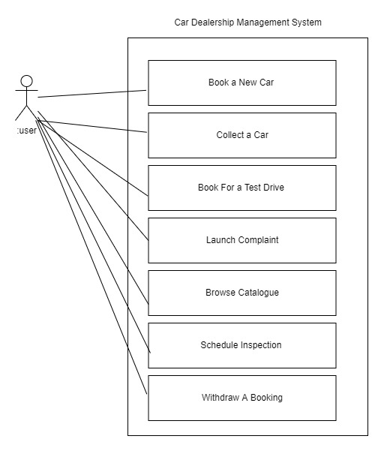

# Class Diagram

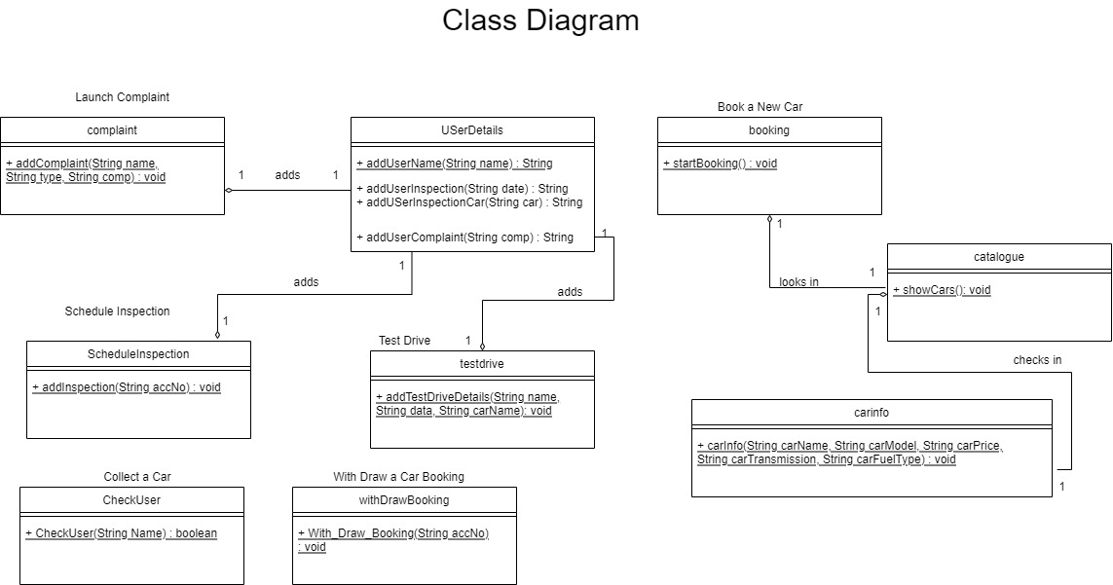

# Domain Model